***CLIMATE CHANGE***

***Submitted by***

**K.SAI SANJANA (192210680)**

***In partial fulfillment for the completion of the***

**Project**



**Department of PROGRamming**

**SAVEETHA SCHOOL OF ENGINEERING**

**SAVEETHA INSTITUTE OF MEDICAL AND TECHNICAL SCIENCES,**

**CHENNAI – 602 105**

**SEP 2022**

**SUPERVISED BY**

**Dr. Vijaya Bhaskar**

**BONAFIDE CERTIFICATE**

This is to certify that the project report entitled **“CLIMATE CHANGES ”** submitted by " K.SAI SANJANA (1921120680) to Saveetha School of Engineering . Saveetha Institute of Medical and Technical Sciences, Chennai, is a record of bonafide work carried out by him/her under my guidance. The project fulfills the requirements as per the regulations of this institution and in my appraisal meets the required standards for submission.

**Dr. Vijay Bhaskar**

**Department of Programming**

**Internal examiner External Examiner**

**ACKNOWLEDGEMENT**

I take immense pleasure in expressing my gratitude to our Honourable Chancellor**, Dr. N. M. VEERAIYAN** for being our constant source of inspiration.

I sincerely thank our Vice-Chancellor, **Dr. L. JAWAHAR NESAN** for providing the academic ambience to complete the project successfully.

With profound gratitude, respect and pride, I express my sincere thanks to our Director, **Mrs. RAMYA DEEPAK**, whose enthusiasm and dynamism being the driving force behind all our accomplishments.

I take this opportunity to extend our heartiest thanks to our beloved Principal, **Dr. Ramesh** for providing us excellent facilities and unstinting support which were the sustaining factors in carrying out the work successfully.

I owe a deep sense of gratitude to **Dr.K.Vijaya Bhaska**r, Department of Programming, for his keen interest on me at every stage of my project.

It is a genuine pleasure to express my deep sense of thanks and gratitude to my mentor Dr. Sungeetha Asst.Prof/Asso.Prof, Department of Nanotechnology. His/her dedication and keen interest had been solely and mainly responsible for completing my work.

Also, I am greatly indebted to my project guide **Dr.K.Vijaya Bhaskar** Department of Biotechnology. His timely advice, meticulous scrutiny and scientific approach have helped me to a very great extent to accomplish this task.

Last, but not least, a very special thanks to my parents and friends for their moral support and care extended during the demanding times.

Climate change is one of the major challenges of our time and adds considerable stress to our societies and to the environment. From shifting weather patterns that threaten food production, to rising sea levels that increase the risk of catastrophic flooding, the impacts of climate change are global in scope and unprecedented in scale. the associated terms, causes, consequences, solutions and its potential health impact. It shows the need to act urgently if we are to avoid an irreversible build-up of greenhouse gases (GHGs) and global warming at a potentially huge cost to the economy and society worldwide . Therefore, addressing climate change requires an unprecedented level of cooperation.

Abstract

Introduction

The evidence of climate change is compelling: sea levels are rising, glaciers are retreating, precipitation patterns are changing, and the world is getting warmer. According to the Intergovernmental Panel on Climate Change (IPCC), the current rate of greenhouse gas emissions is likely to cause average temperatures to rise by 0.2˚C per decade. Climate change indeed is real. Super typhoon Haiyan is the latest natural disaster for Economic Co-operation and Development (OECD) analysis suggests that if we act now, we have 10 to 15 years’ “breathing space” during which action. This sad occurrence hit land and devastated the Philippines. This record-breaking storm is the strongest storm in history to make landfall. It tore apart buildings and left entire provinces without power.

Burning fossil fuels generates greenhouse gas emissions that act like a blanket wrapped around the Earth, trapping the sun’s heat and raising temperatures. Examples of greenhouse gas emissions that are causing climate change include carbon dioxide and methane. These come from using gasoline for driving a car or coal for heating a building, for example. Clearing land and forests can also release carbon dioxide. Landfills for garbage are a major source of methane

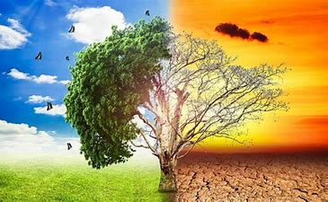

Climate change is a serious risk to poverty reduction and could undo decades of development efforts. While climate change is global, its negative impacts are more severely felt by poor people and poor countries. They are more vulnerable because of their high dependence on natural resources and limited capacity to cope with climate variability and extremes. We need to act urgently if we are to avoid an irreversible build-up of green- house gases (GHGs) and global warming at a potentially huge cost to the economy and society worldwide. Organisation for Economic Co-operation and Development (OECD) analysis suggests that if we act now, we have 10 to 15 years’ “breathing space” during which action .

**ADVANTAGES**

**Generating power**

Generating electricity and heat by burning fossil fuels causes a large chunk of global emissions. Most electricity is still generated by burning coal, oil, or gas, which produces carbon dioxide and nitrous oxide, powerful greenhouse gases that blanket the Earth and trap the sun’s heat.

**Cutting down forests**

Cutting down forests to create farms or pastures, or for other reasons, causes emissions, since trees, when they are cut, release the carbon they have been storing

**Manufacturing goods**

Manufacturing and industry produce emissions, mostly from burning fossil fuels to produce energy for making things like cement, iron, steel, electronics, plastics, clothes, and other goods.

**Cutting down forests**

Cutting down forests to create farms or pastures, or for other reasons, causes emissions, since trees, when they are cut, release the carbon they have been storing

**Using transportation**

Most cars, trucks, ships, and planes run on fossil fuels. That makes transportation a major contributor of greenhouse gases, especially carbon-dioxide emissions

**DISADVANTAGES**

**More severe storms**

Destructive storms have become more intense and more frequent in many regions

**Hotter temperatures**

And[emissions continue to rise](https://wedocs.unep.org/bitstream/handle/20.500.11822/36991/EGR21_ESEN.pdf). As a result, [the Earth is now about 1.1°C warmer](https://www.ipcc.ch/2021/08/09/ar6-wg1-20210809-pr/) than it was in the late 1800s. The [last decade (2011-2020) was the warmest on record](https://public.wmo.int/en/media/press-release/2020-was-one-of-three-warmest-years-record).

Many people think climate change mainly means warmer temperatures. But temperature rise is only the beginning of the story. Because the Earth is a system, where everything is connected, changes in one area can influence changes in all others.

The [consequences of climate change](https://www.ipcc.ch/report/ar6/wg2/resources/press/press-release) now include, among others, intense droughts, water scarcity, severe fires, rising sea levels, flooding, melting polar ice, catastrophic storms and declining biodiversity.

**LITERATURE REVIEW 1**

**JOURNEL BY MAJOR PROFESSOR: Dr. Leslie A. Duram (2009) Evaluating the potential use of winter cover crops in corn soybean systems for sustainable co-production of food and fuel.**

Cities are vulnerable to climate change, but they are also uniquely positioned to lead the way in both mitigating and adapting to it. While there is no single solution to climate change, cities have a responsibility to transition toward a more sustainable future.

to examine how climate change is affecting urban areas; (2) to assess how cities can enhance urban sustainability by addressing climate change; (3) to discuss resources available for city leaders wanting to transition to a sustainable city. These objectives are addressed using a literature reviewcities have a responsibility to transition toward a more sustainable future.

**LITERATURE REVIEW 2**

**JOURNEL BY Students: Fabio Kunc kel, Samuel Dennis Mietke, Timur Sroka (2017) . The combined and separate impacts of climate extremes on the current and future US rainfed maize and soybean production under elevated CO2.**

Global warming is one area of research that has been steadily increasing in discussions along the last decades. With temperatures increasing around the globe and natural disasters happening in higher frequency, businesses are starting to pay more and more attention to it since it will impact the future of the whole global population, especially in littoral areas and places prone to natural disasters. Since 2010, The objective for this systematic literature review is to generate awareness of what kind of research is being published in the field of climate change and business, within the time frame of 2010 to 2021.

**LITERATURE REVIEW 3**

**JOURNEL BY Stéphanie Jamet and Jan Corlo Morlot (1996). Sensitivity of the US Corn Belt to Climate Change and Elevated.**

Climate change is expected to have significant implications for the world economy and, more broadly, for many areas of human activity. The purpose of this review is twofold. First, it is to summarize current estimates of the impacts of climate change and to explain how these estimates are built in order to identify the main sources of uncertainty and approximation affecting them fond, the paper discusses how this uncertainty should influence policy makers decisions. A main conclusion is that there are large uncertainties in existing estimates of global impacts of climate change in monetary units.

**LITERATURE REVIEW 4**

[**JOURNEL BY Elena Sesana**](https://wires.onlinelibrary.wiley.com/action/doSearch?ContribAuthorRaw=Sesana%2C+Elena),[**Alexandre S. Gagnon**](https://wires.onlinelibrary.wiley.com/action/doSearch?ContribAuthorRaw=Gagnon%2C+Alexandre+S),[**Chiara Ciantelli**](https://wires.onlinelibrary.wiley.com/action/doSearch?ContribAuthorRaw=Ciantelli%2C+Chiara),J[**oann Cassar**](https://wires.onlinelibrary.wiley.com/action/doSearch?ContribAuthorRaw=Cassar%2C+JoAnn) **(2007). Vulnerability and adaptation to climate risks in Ontario agriculture. Mitigation and Adaptation Strategies for Global Change, 12: 609‒637**

huge significance especially for Climate change, as revealed by gradual changes in temperature, precipitation, atmospheric moisture, and wind intensity, as well as sea level rise and changes in the occurrence of extreme events, is already affecting cultural heritage sites. Accordingly, there is a rapidly increasing body of research reporting on the impacts of climatic stressors on cultural heritage and on the assessment of climate change impacts on cultural heritage assets. This review synthesizes the (1) the cultural heritage exposed to the outside environment, (2) the interiors of historical buildings and their collections

**LITERATURE REVIEW 5**

**Reilly, J.M. and Schimmel pfennig, D., (1999). Agricultural impact assessment, vulnerability, and the scope for adaptation. Climatic Change, 43: 745‒788**

This paper provides a comprehensive review of various reports, articles documents and papers literature related to the assessment of climate change impacts on crop productivity, and will focus on how climate change and affects agriculture productivity. Agricultural practice is affected by climate changes because of its direct dependence on climatic changes. There are two methods of relationships between agriculture and climate change and has developing and low-income countries.

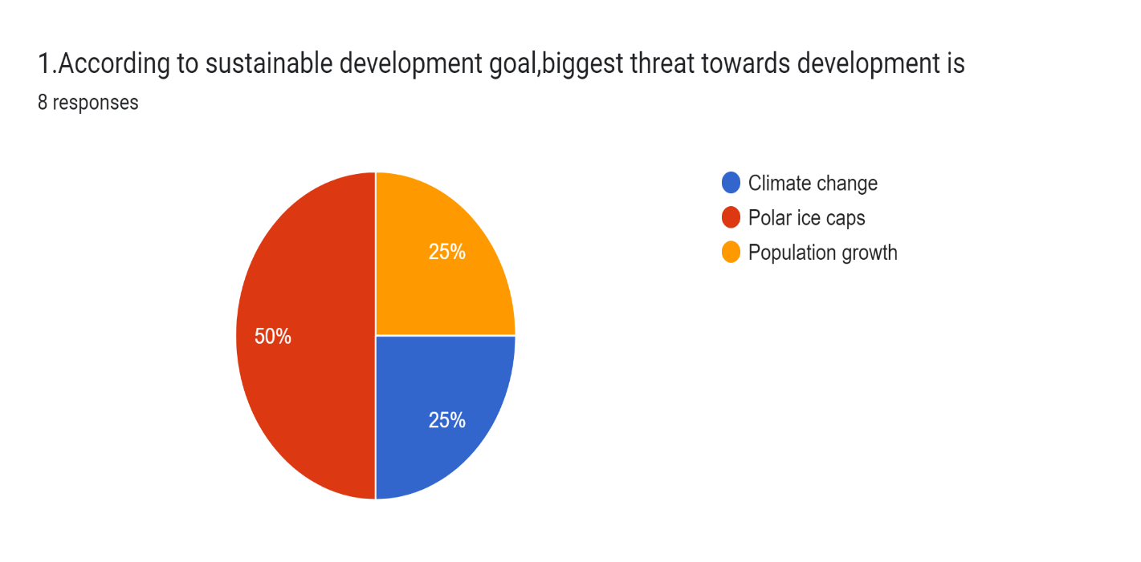

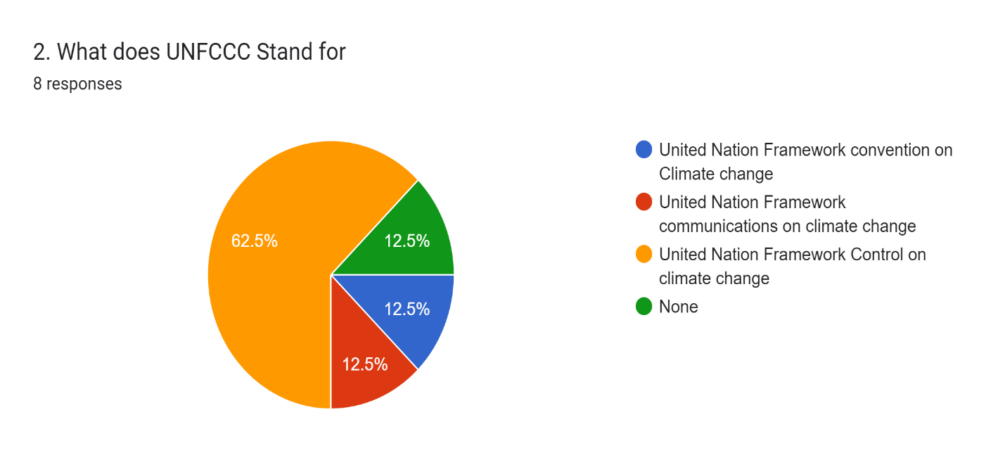

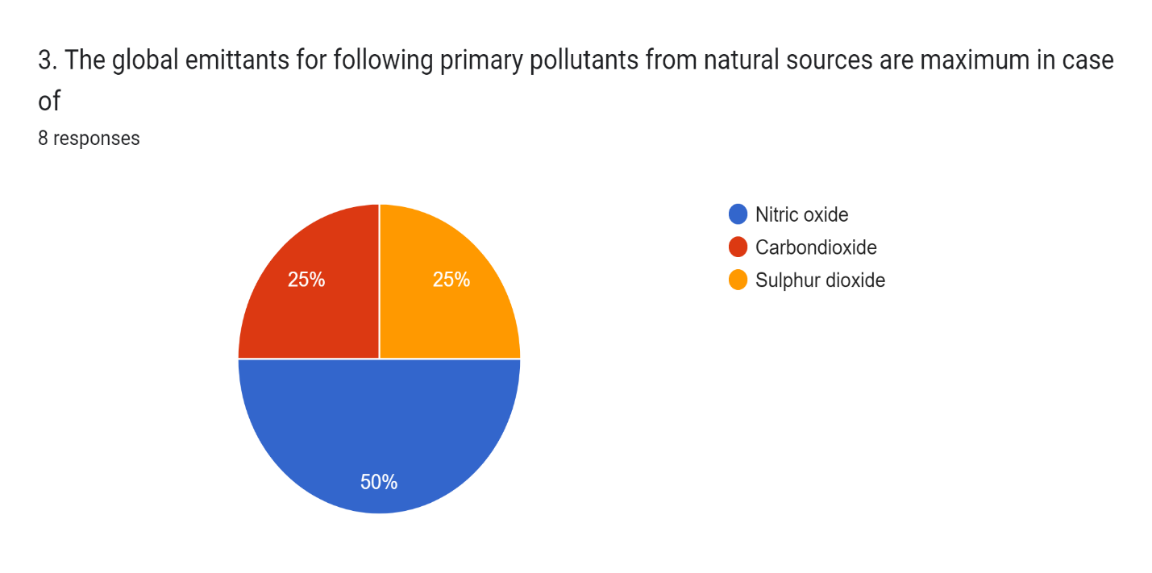

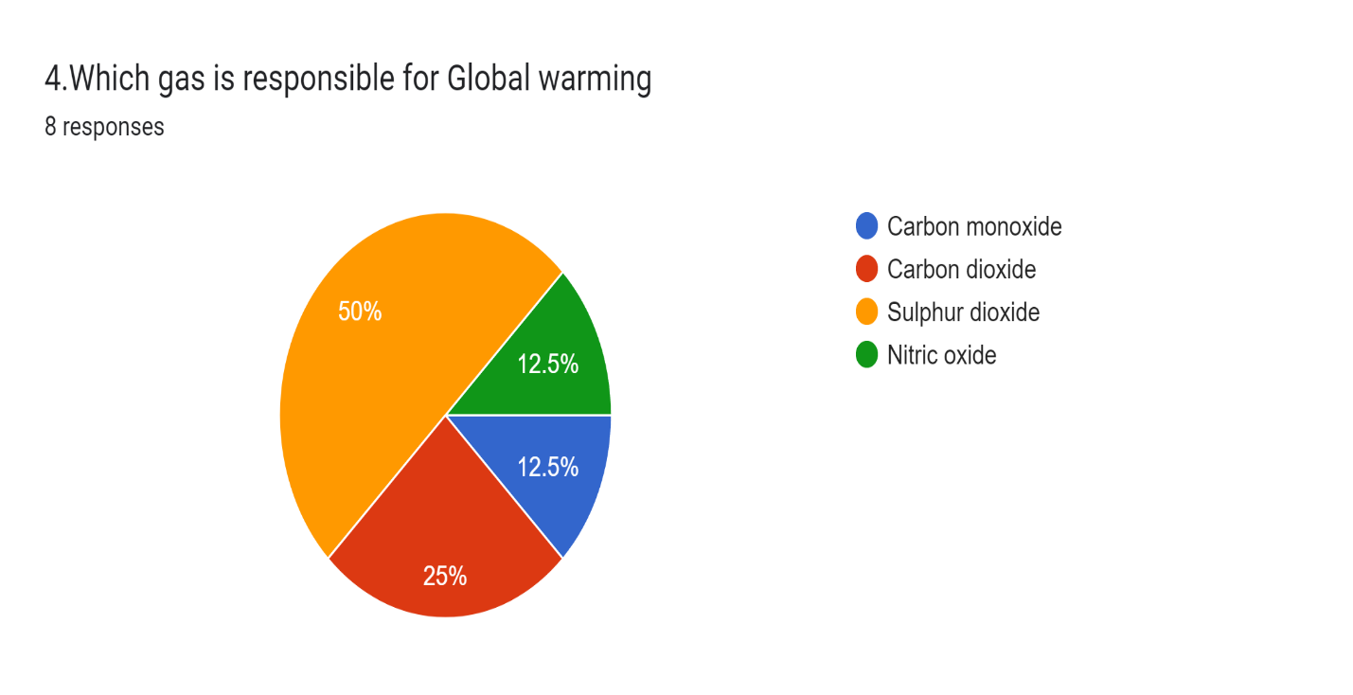



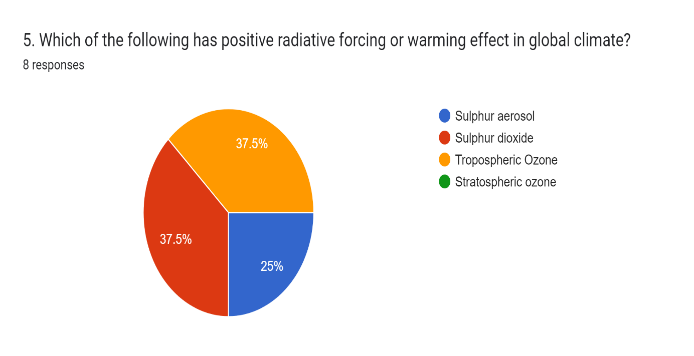

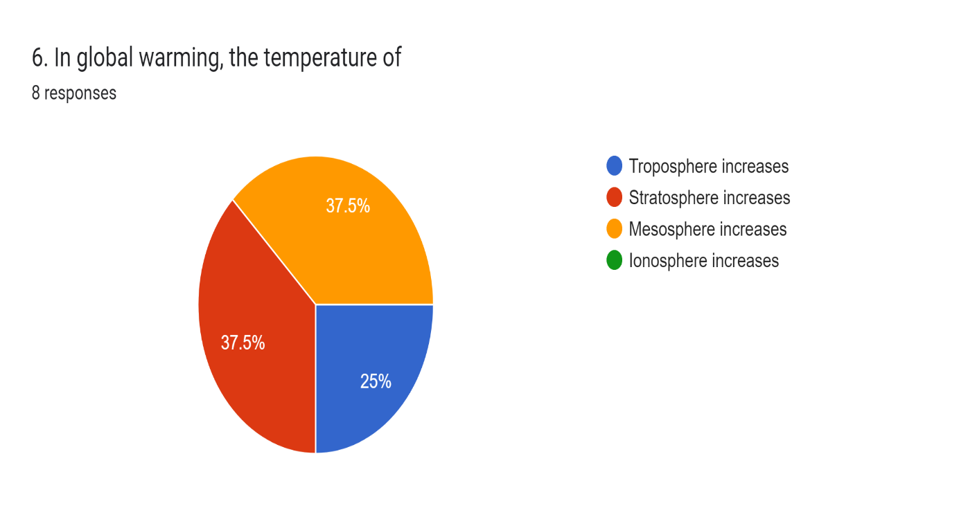

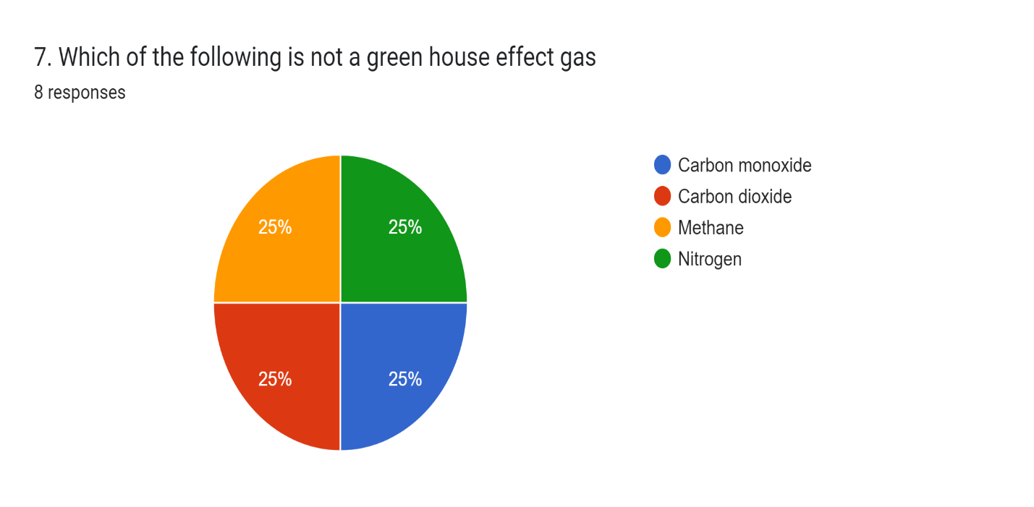

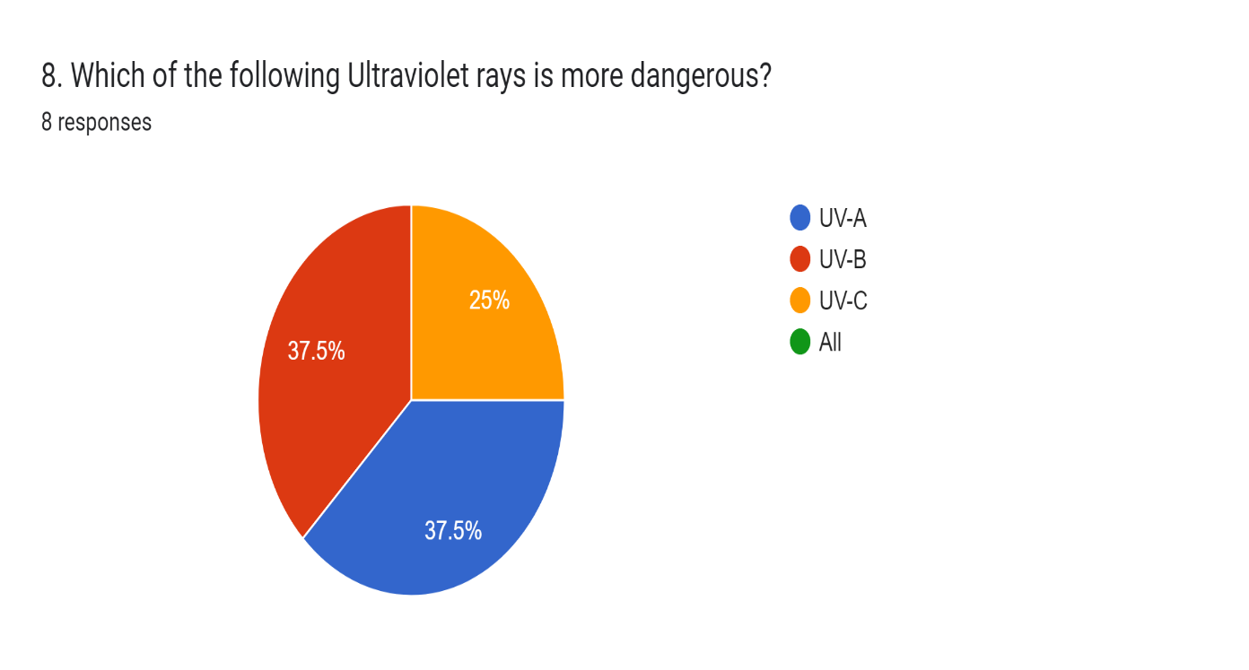

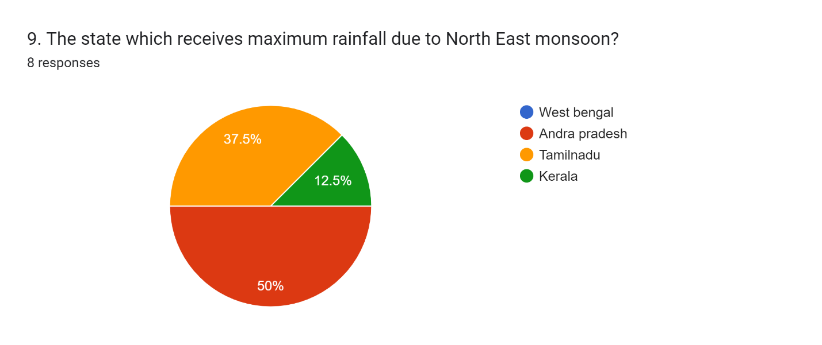

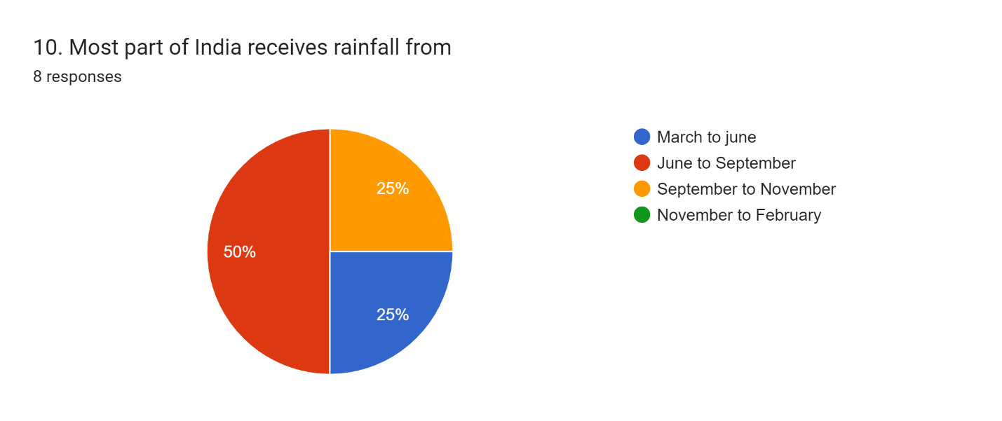

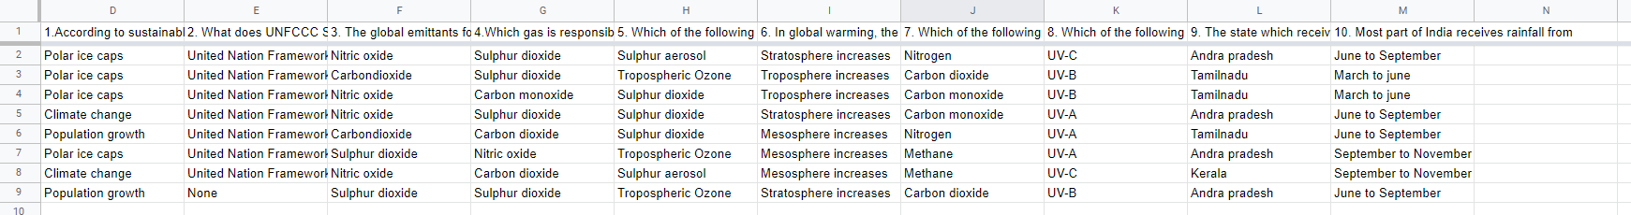

**OBSERVATION AND RESULT**

The Above conducted survey shows that the climate change is carried by Environment

* It shows that the survey was effective and friendly
* It shows that the Phone cells are promptly answered by the staff
* It shows that all the people are getting awareness of the climate change.
* It shows that many people are taking initiative to decrease the global warming.

**OBJECTIVES**

* To improve awareness and understanding of climate change amongst citizens;
* To demonstrate that daily activities can collectively make a big difference and that each individual has a role to play in the fight against climate change; and
* To motivate citizens to undertake these small, significant changes to their daily routine.

**CONCLUSION**

Climate change is happening and it is caused largely by human activity. Its impacts are beginning to be felt and will be worsen in the decades ahead unless we take action. The increasing rate of global warming courtesy of carbon dioxide and other greenhouse gas emissions from human activities have led to climatic changes and environmental degradation, which in turn have resulted to great challenges in relation to diseases and human health. Many diseases which were previously unknown in certain climatic zones are now finding their way to such areas, due to changes in the weather conditions. conditions that favor their comeback.

This kind of deal is therefore important that stakeholders and decision makers at industrial, government and international policy levels come up with stringent and workable means of cutting down on greenhouse gases emission to combat which has produced devastating impacts especially among poorer nations. Further, there should be increased funding of adaptation and coping programs and projects in affected areas to minimize the impacts on human health and curtail the spread diseases. The simulated effects of climate change on yields in rainfed corn-soybean rotation systems in the Eastern US varied depending on the climate model used, ranging from decreases to increases. Mean corn yields experienced decreases of 15‒51% and increases of 14‒85% while mean soybean yields experienced decreases of 7.6‒13% and increases of 22‒170%. Yield decreases were most common under the climate model predicting the highest increase in temperature and a reduction in precipitation, whereas yield increases were most common in the climate models predicting either a relatively small increase in temperature or a relatively large increase in precipitation. The effects of climate change on yields were often not constant throughout the 30-year future period (2041‒2070), but worsened with time. In some cases, climate change increased yields at first and then decreased them or had no effect, and in others cases climate change had no effect at first and then decreased yields.

The effects of climate change differed between the northern, central, and southern regions of the Eastern US, generally improving with latitude. While yields often increased in the northern region, especially in the case of soybeans, the southern region experienced mostly decreases or no changes

**REFERENCES**

1. Climate Change Information Resources, New York Metropolitan Region. http://ccir.ciesin.columbia.edu/nyc/pdf/q1a.pdf
2. Epstein, P. R. (1999). Climate and Health. Science, 285, 347-348.
3. Harvard, & Chivian, E. (2002) Biodiversity: Its Importance to Human Health Harvard Medical School.
4. IPCC Online, Glossary of Terms Used in the IPCC Third Assessment Report (2001) IPCC_Third_Assessment_Report (Accessed December 2009). http://en.wikipedia.org/wiki/
5. Langford, I. H., & Bentham, G. (1995). The Potential Effects of Climate Change on Winter Mortality in England and Wales
6. McMichael, A. J., & Githeko, A. Human Health. In: Climate Change 2001: Impacts, Adaptation, and Vulnerability. Contribution of Working Group II to the Third Assessment.
7. <http://www.thegreatwarming.com/pdf/ClimateChangeFactSheet.pdf>
8. Rens Kortmann (CE Delft), Edgar Peigenborgh (RPS), Judith Harewjin, Lindske van Hulst (SME Advies) (2007). Climate
9. Change: Causes, Consequences, and Solutions, Scientific Background to the On-Line Platform Climate Quest.
10. Rooney, C. et al. (1998). Excess Mortality in England and Wales during the 1995 Heatwave. Journal of Epidemiology and
11. Community Health, 52, 482-486.
12. Shindell , D. T. et al. (1998). Increased Polar Stratospheric Ozone Losses and Delayed Eventual Recovery Owing to Increasing Greenhouse Gas Concentrations. Nature, 392, 589592.
13. http://www.climate-leaders.org/wp-content/uploads/global-climatechange-sudipmitra.pdf
14. The Argo (2013) Typhoon Haiyan Hits Philippines: Stockton Community Takes Action, The Independent Student Newspaper